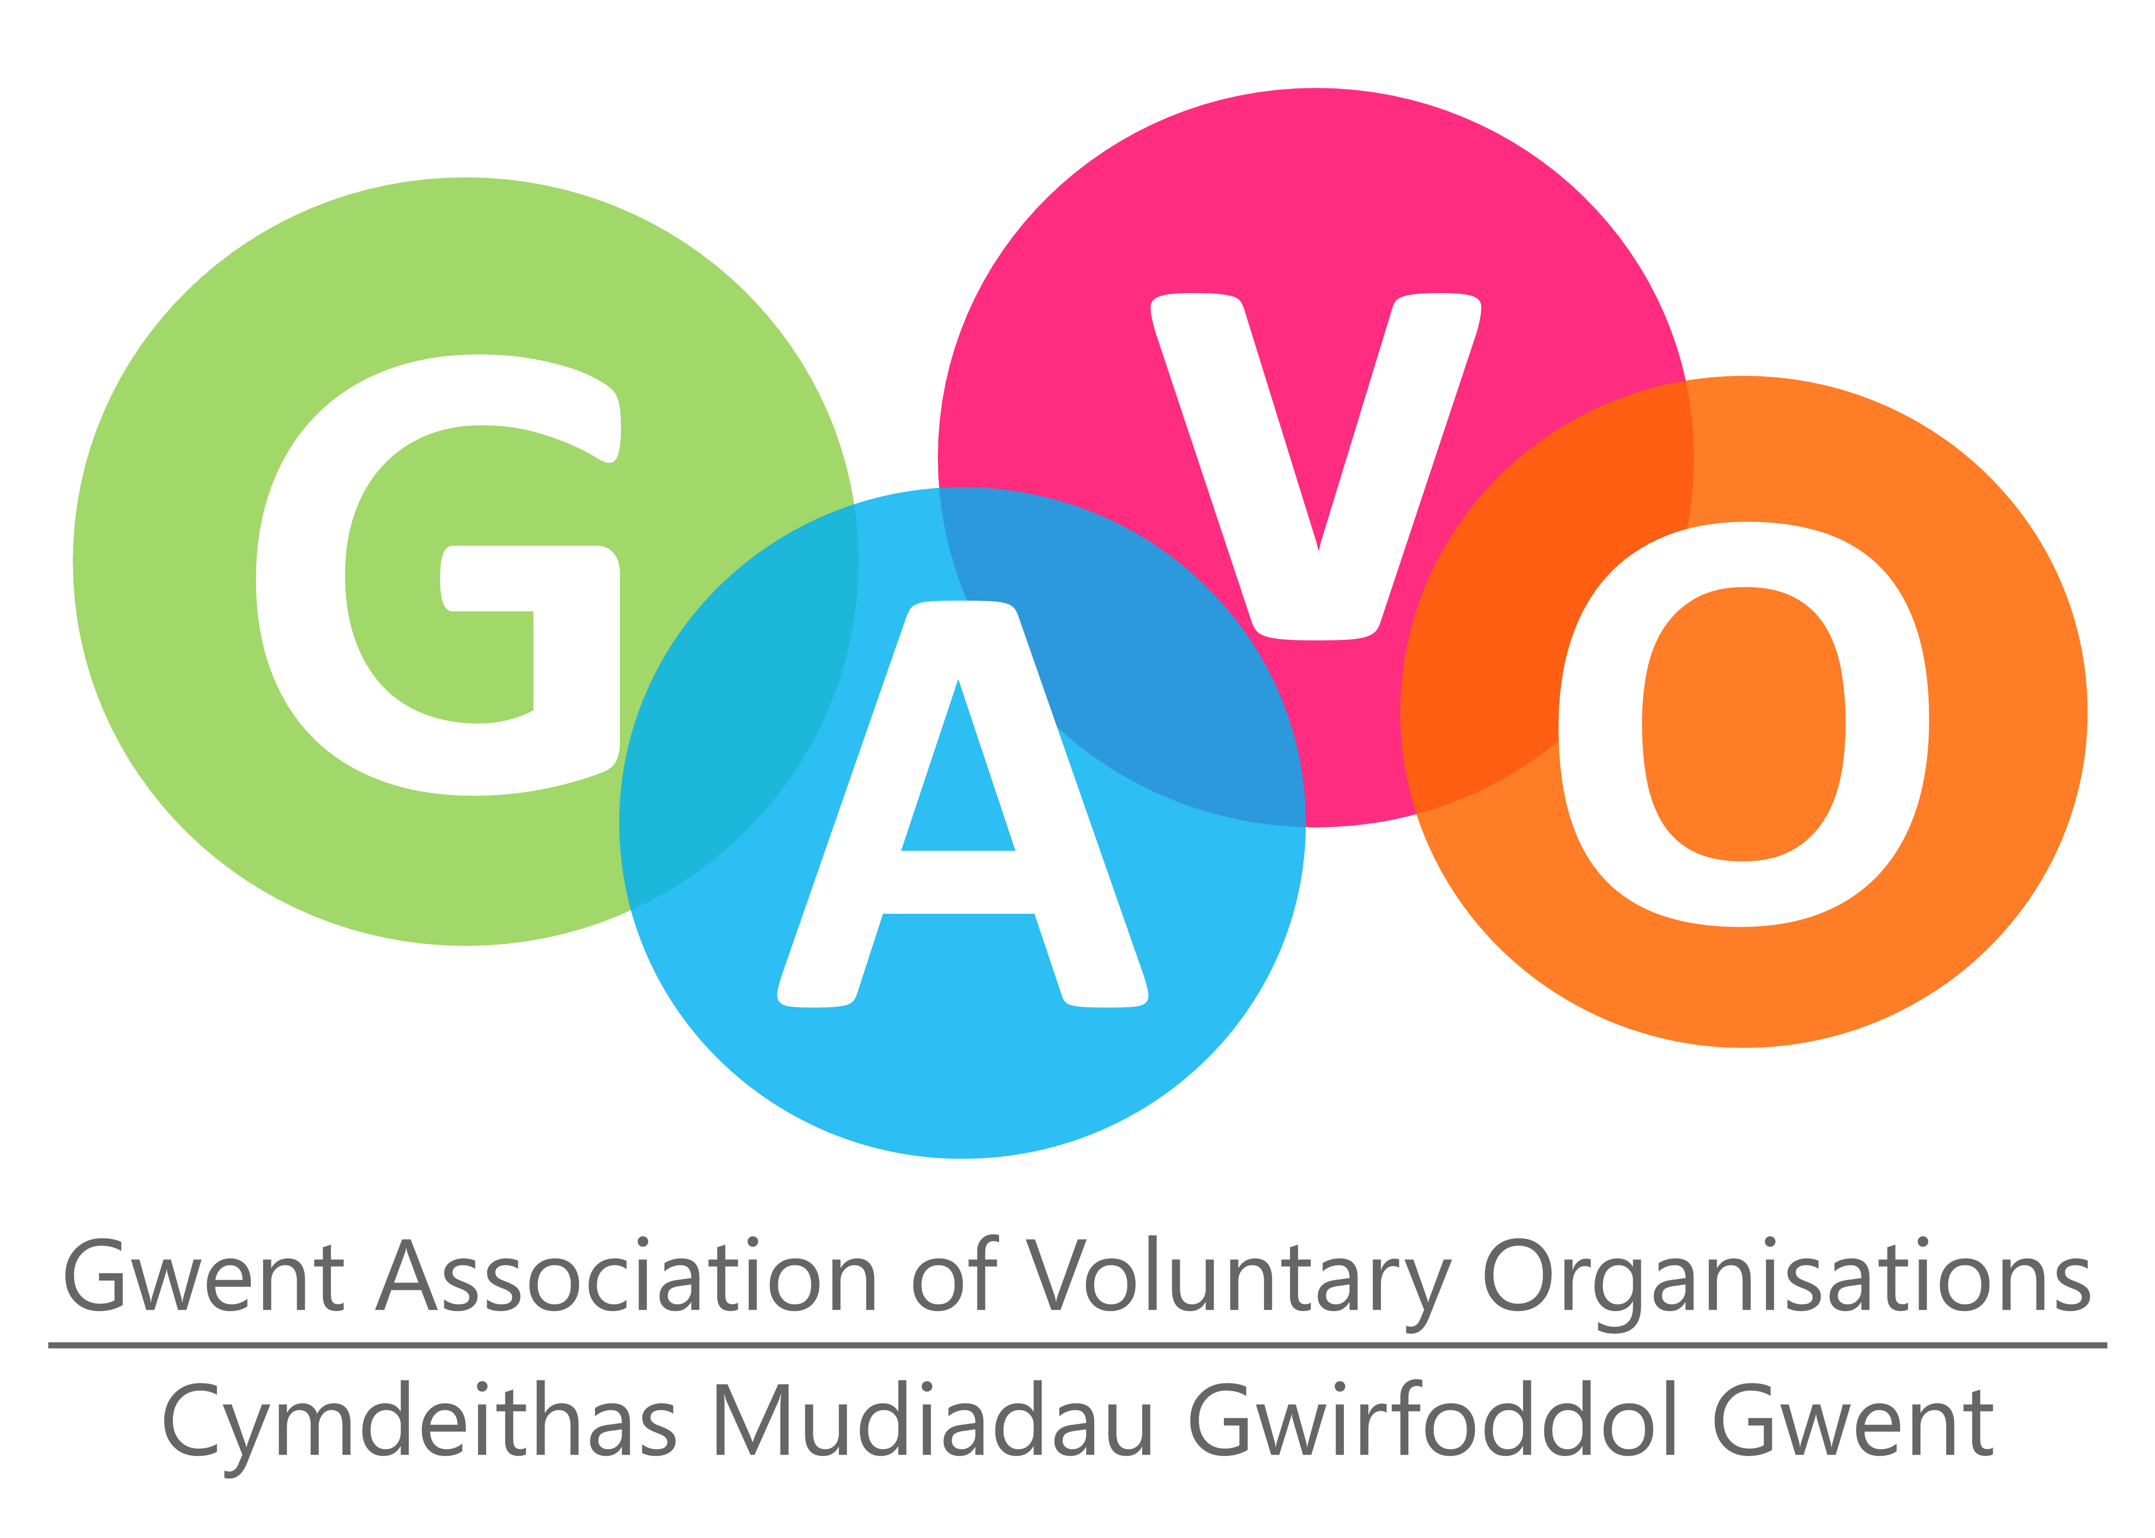 |  |  | 
Cwtsh Community Wellbeing Connections Fund 2025-2026
Application Form
- Please read the attached guidance notes before completing the application form
- Please send your completed application form to heather.r.manson@wales.nhs.uk by 13th March 2026
GENERAL INFORMATION
Name of Organisation
Name of Contact
Please give title, first name and surname
Position in Organisation
Address for Correspondence

Title of Project
Location of Project for which grant is sought (if different from above)
Email contact
Contact Telephone Numbers |  | Daytime:  Alternative Number:
Amount of Grant Applied for:  (Total brought forward from page 4) |  | £

INFORMATION ON YOUR GROUP OR ORGANISATION
Is your organisation a Registered Charity? |  |  |  |  |  | YES / NO *  please delete as appropriate
Is your organisation a Company Limited by Guarantee |  |  |  |  |  | YES / NO *  please delete as appropriate
Is your organisation a Charitable Incorporated Organisation? |  |  |  |  |  | YES / NO *  please delete as appropriate
Is your organisation a Community Interest Company |  |  |  |  |  | YES / NO *  please delete as appropriate
If yes, give Registration Numbers

Please enclose the following with your application - þ tick if enclosed
Constitution or governing document
Current bank statement
Relevant policies
How would you describe your organisation: Please þ the nearest description
A constituted community organisation
A constituted community sports organisation
A self-help group
An environmental group
Other (please describe below)
Please briefly describe your organisation's work and list its aims and objectives (these should be on your constitution)
PROJECT DETAILS
please refer to the guidance
Please give details of how you want to use the funding
Please describe how your project will help deliver the aims of the Cwtsh Community Wellbeing Connections Fund and support and enhance wellbeing (see guidance). How will it benefit members of the community, including those who are disadvantaged, lonely and isolated?
How many people will benefit directly from your project?
(The number of people in your group and any members of the community directly benefitting from your project)

When will your project start?
How long do you think it will take to complete?

Is this application for whole or part of the cost of your project? (please tick)
Whole |  |  |  |  | Part
Please give details of any other funding you have received, or have applied for to fund all/part of this or a related project or activity.
Funding Body |  |  | Amount Applied For |  |  |  | Amount Received |  |  | Date of end of funding
FINANCIAL DETAILS
Please give a breakdown of the costs you are applying for funding for
Please itemise expenditure |  |  |  |  |  |  |  |  |  | Amount (£)
Insert more rows if necessary
Total Applied For
Copy this figure to Page 1
BANK ACCOUNT DETAILS
Account Name: (Please give the full name - this must be the group’s/organisation’s account and cannot be an individual)
Account Number:
Sort Code:
Bank Address:
All payments will be made by BACS unless otherwise requested

Signed on behalf of organisation |  |  |  |  | Print Name
Position in Organisation

All information given on this Application Form will be processed and kept by Gwent IWN and GAVO both electronically and manually in line with the General Data Protection Regulation legislation. The information will be used by Gwent IWN and GAVO for the administration, monitoring and promotional purposes of the Grant scheme. Copies of this information will be provided to our Panel for the purposes of decision-making but will not be retained by Panel members.

